Chapter 1: Introduction

1.1. Introduction about the project subject

Rental services for motorcycles are becoming more and more well-liked as a practical and economical option for people to travel or commute inside their city. In recent years, these services have been boosted by the introduction of Industry 4.0 technologies, which enable better data management and consumer experiences. Technology has completely changed how businesses manage their data. Manual paper-based data management is no longer used since it was time-consuming, prone to error, and ineffective. Organizations may now handle their data in a more streamlined and effective manner because to the advancement of digital technologies.

Businesses may store, process, and analyze data more quickly and correctly by using software applications, cloud-based storage solutions, and automation tools. As a result, they are able to make better decisions and perform better as a whole. With modern enterprises producing an increasing amount of data, manually managing it can rapidly become overwhelming. Adopting technology may help organizations stay organized, compliant, and competitive in an increasingly data-driven environment.

Vietnam is known for having one of the largest populations of motorbike users in the world, making motorbike rental services a thriving industry in many tourist destinations. However, it is common to find many of these motorbike rental service providers still relying on outdated and manual methods to manage their data. This can lead to several challenges, including inefficient processes, potential errors, and limited access to accurate information. By adopting modern technology solutions for data management, these businesses can streamline their operations and improve their customer service. With technology, rental providers can easily track their bikes, manage rental schedules, and automate tasks such as invoicing and customer communication. Additionally, it can help businesses to gain valuable insights through real-time data analytics, leading to better decision-making and a more competitive edge. Embracing technology is no longer a luxury but a necessity to remain relevant in today's rapidly evolving business landscape. Therefore, it is essential for motorbike rental service providers in Vietnam to adopt modern technology solutions to help manage their data effectively and remain competitive.

Based on the aforementioned factors, I made the decision to work on this project to create a website management system that enables small enterprises or individuals to control all data as well as the motorcycle rental procedure. ReactJS and Spring Boot, two well-known technologies that will be used in this project, will give me the opportunity to study and practice them.

1.2. Project objectives

Here are some possible objectives for a project to build a website data management system for motorbike rental field:

1. Simplify the booking process: The website data management system should make it simple for customers (admin) to book motorcycles, check availability, and securely pay.
2. Improve operational efficiency: Key processes such as rental management, maintenance, and inventory tracking should be automated and optimized by the system.
3. Enhance customer experience: The system should have an easy-to-use interface and make personalized recommendations based on the customer's preferences and rental history.
4. Ensure data security and compliance: The system should be designed with strong security measures to protect customer data and comply with data privacy regulations.
5. Increase data accuracy: By automating data entry and providing accurate reports on the dashboard, the system should reduce errors and improve data accuracy.
6. Enable real-time reporting: To assist managers in making data-driven decisions, the system should provide real-time reporting and analytics.
7. Scale the business: The system should be able to accommodate future growth and expansion by supporting multiple locations, integrating with other systems, and providing tools for marketing and customer engagement.

The objectives listed above are required for a project of mine to run smoothly. As we can see, these criteria can be used to assess the project when it is finished.

1.3. Project plan

Planning is an important step in any motorcycle rental project because it helps determine the key activities and resources needed to achieve the project's objectives. Planning necessitates an understanding of the entire project, as well as the time, resources required, and priority of each specific task. To properly plan this project, I used a Gantt Chart to represent each task. This is a tool that can show a manager a visual representation of the project's progress. A Gantt Chart is a timeline that outlines all of the tasks and activities involved in the project as well as their dependencies. During this planning phase, using a Gantt Chart is an effective way to manage a motorbike rental project by helping me monitor the time of each job to reduce the risks in the project.

For the aforementioned reason, I will show the Gantt Chart in this section, which lists the tasks that need to be accomplished during the Motorcycle Rental Management System project's development phase:

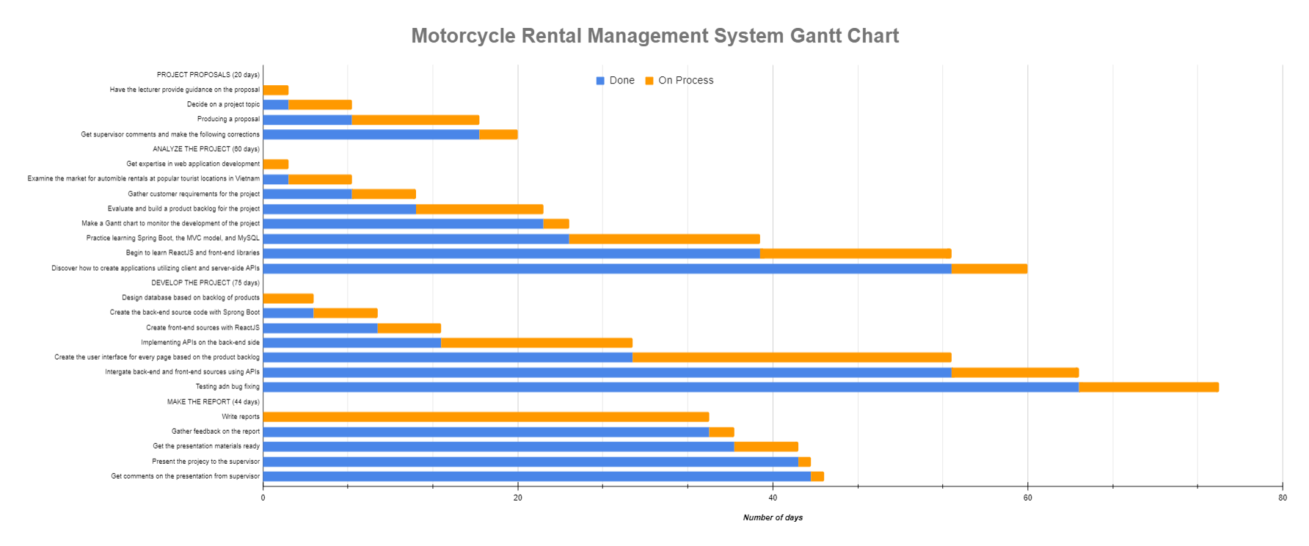We will have 4 primary phases for the main procedure, which will include:

**PROJECT PROPOSALS**: 20 days. My supervisor will help me choose a topic for the project at this point. After giving it some thought, I decided to write about creating a website application to handle automobile rentals. At this stage, I typically compose the proposal that the supervisor has requested for this topic.

**ANALYZE THE PROJECT**: Because I have a lot of business-related duties to complete, this may be considered one of the most essential phases of the project. The current tasks can be divided into the following three groups.

* The initial step is to gather customer requirements. I discovered a family that offers motorbike rentals in Nha Trang (This is one of the famous tourist destinations in Vietnam). Presently, they keep running the motorbike rental business by hand-calculating the money and writing on billboards and in their personal notebooks. After discussing, this family realized I was creating a website to assist them manage more effectively. They consented to assist and fulfill my customer's requirement. From there, I gained an understanding of the vehicle rental process as well as a list of needs for a rental management system.
* The second crucial step is to examine the requirements in order to create a project backlog. A project backlog is a prioritized list of the tasks, requirements, features, and improvements that must be finished in order to meet the objectives of the project. This data collection and analysis took me roughly 15 days in total.  In addition, I refer to other similar applications and compare them to the customers' requirements. We then filtered out the project's requirements as well as scenarios to complete the Project Backlog. Then, I created a Gantt Chart to display the project progress once I had a list of requirements and priorities. Looking at the Gantt Chart, we can easily see each task's timetable.
* The final task in this phase is to research and understand the technologies, processes, and associated expertise that will be required while developing a management system via a website. This is the stage when I will learn more about ReactJS and Spring Boot, as well as the process of developing a system from beginning to end. Because it is the learning period, the tasks are almost often very long, lasting more than a month. During this time, I largely studied on the internet. By the conclusion, I had learned the fundamentals of deploying a tiny application utilizing new technologies.

**DEVELOPE THE PROJECT**: The implementation phase is a critical stage in building software because it involves transforming the design and specifications into an actual functioning system. During this phase, the development team codes, integrates, and tests the software to ensure it meets the specified requirements and functions as intended. In the coding section, I'll go over the task:

* The first step is to create two source code projects: ReactJS (front-end) and Spring Boot (Back-end). I generated the two most basic sources in order to run a small project and configure other relational libraries. For Spring Boot, I focused on configuring security and connecting to the database (MySQL). In addition, I researched and added libraries for ReactJS that support interface creation, data validation, API connection, and so on.
* After ensuring that two sources were stable and capable of communicating with one another, I proceeded to complete each function on the product backlog. This is the most time-consuming part of the project. The following is the work order: First, I'll analyze the screen and create the necessary entities (tables in the database). When I have the entities, I'll start coding the back-end API to handle data processing for that website. Then I began designing the database-driven interface. For ReactJS, I also create small reusable components for web pages with similar functionality. After creating the interface, I proceed to integrate the data from the back-end and front-end.
* The final step is testing and debugging. When a function or a page is finished, I will test it in a variety of scenarios. When an issue arises, I will resolve it immediately and ensure that it does not occur again.

**WRITE REPORT**: This is the final stage after the product has been completed. I spend most of my time completing the report requested by the supervisor. When I finish the report, I'll start working on the presentation material. As a result, the project came to a successful conclusion.

1.4. Project outcomes

Certain criteria are required for every project. Based on those criteria, we can gradually improve the project. Following that, I will share the outcomes of the Motorcycle Rental Management System project.

* Completed product: The successful delivery of a product to users is the most important outcome of a software development project. My customer will receive a product with all of the basic functions for managing motorbike rentals at the end of this project.
* Improve my knowledge: When this project is finished, I will have a better understanding of new frameworks such as ReactJS and Spring Boot. Aside from technical knowledge, I will also learn how to manage projects, collect and analyze requirements, create detailed plans, draw charts, use project management tools, and so on. This project, it can be said, has created a favorable environment for me to develop myself in all aspects of information technology.
* Product quality: Products must satisfy customers in terms of user experience. Furthermore, every function must be error-free and accurate. It is bad if the product contains numerous errors while in use; it is an extremely unpleasant experience. More than that, I want the software to be simple to use and accessible to all users after just one tutorial. Furthermore, I will design the application so that it can be accessed by customers on any platform, such as phones or computers. With so many functions and criteria, each function must be completed with care and polish.
* The best user interface: I needed to make sure the interface was vibrant and colored to match the tones provided by the customer because it was built and handcrafted by me. To tailor the interface to the user's satisfaction, I will need to select a large number of theme templates for the "Motorcycle rental" theme. I am aware that my self-created interface will not look as good as the templates available online, so I must carefully study the layouts, colors, details, and images to perfect them.
* Documentation and Presentation: At the end of this project, I must complete the report and proposal. To meet the supervisor's criteria, I must include all project-related information in the report section. In addition, I must prepare the presentation using the Powerpoint tool.

1.5. Project evaluation

In this section, I will go over the Motorcycle Rental Management System project in detail. I will divide the evaluation into two parts: Project development process and final product evaluation.

**Project development process evaluation:**

* Overall, the project schedule management process appears to have gone smoothly and efficiently. The first is about meeting project goals; it can be seen that all of the client's and my goals have been completely met. The customer received a fully functional product on time. In terms of new technologies, I've learned about ReactJS, Spring Boot, and related libraries. As a full-stack developer, I've gained enough knowledge to create a complete website.
* The second factor is customer and supervisor satisfaction. The supervisor determined that the product met all of the basic requirements for the system to function. Customers believe that the product works well, but the interface is unimpressive because the entire interface is built by hand and does not use any free templates.
* Third, I will assess the project management procedure. The project was completed on time thanks to a well-thought-out plan. Except for the development phase, every stage of the product development process runs smoothly. Because the customer made numerous change requests during the coding process, some tasks were delayed. Furthermore, because the project was completed concurrently with my learning new technology, fixing bugs took a long time. Despite the fact that there were numerous such issues during the development phase, the product was completed on time and all processes were free of major issues.
* I'll then go over risk management. As I previously stated, because I have a clear plan, I have covered the majority of the potential risks, from the timeline to the product, as well as other objective factors. There is only the risk of work progress being halted due to a change in the customer's requirements, but I have it under control.
* Finally, because the product is handmade by me, I only use Word to document the project's information. These doc files are stored on my laptop. I only keep the source code on git. This is also a constraint because if my laptop fails, I will lose all of my documents. On this point, I believe the document management is inadequate.

**Final product evaluation:**

* First, I'll assess the functionality: The website already has all of the necessary functions to work, but no advanced functions have been added. CRUD is at the core of all major functions (Create - Read - Update - Delete).
* Second, I will evaluate User Experience: After demoing the product to customers, they confirmed that every function is simple to use. However, a tutorial is required for those who are just getting started with it. The interface of the website is quite rudimentary and unprofessional. This UI will be temporarily acceptable if used for a household or a small business. However, if used for a large corporation, the interface must be significantly upgraded.
* The third point is about security: Because security is configured from Spring Boot and ReactJS uses decentralization, the system can be described as decentralized and extremely secure.
* ourth, this website has been designed to run on both computers and phones using browser platforms such as Chrom, Coc Coc, Microsoft Edge, and others.
* The fifth important factor is performance: Because the application only contains basic functions and a small amount of data, the performance is excellent. The loading of images is currently the website's weak point because the image data is saved by firebase, so it is dependent on the response speed of firebase.
* The following section is about analytics: The system already includes analytics in the dashboard, which displays all of the information required by customers. The analysis is illustrated with colorful charts.
* Finally, there is maintenance and support: Because it is a small system with no advanced functionality, it is very simple to maintain and support the customer. I optimized the lines of code so that any developer could read and upgrade them.

Chapter 2: Literature Review

2.1. Web application

First, we'll go over the definition of a Web application:

A web application is a software application that runs on a web server and can be accessed via the internet using a web browser. With the benefit of being accessible from any location with an internet connection, it is made to offer functionality and a user interface that are comparable to those of a desktop application.

Web applications can be accessed through any web browser-enabled device, including desktop computers, laptop computers, tablets, and smartphones. They are frequently built to be highly scalable, allowing them to easily handle large numbers of users and data.

Online banking systems, social media platforms, e-commerce websites, and productivity tools such as Google Docs are examples of web applications. They can be built with a variety of programming languages and frameworks, and they typically rely on server-side technologies like PHP, Java, Ruby, or Python to manage backend logic and database interactions.

As a result, we can see that web applications are widely used in today's society, particularly during the 4.0 period. It enables businesses, organizations, and individuals to use the internet's power to deliver services and information to everyone quickly, efficiently, and easily. In this section, I will discuss some of the factors that distinguish web applications:

* Digital Transformation: With the introduction of 4.0 technology, an increasing number of businesses are looking to digitize their operations and processes in order to improve efficiency and competitiveness. Web applications can assist them in making this transition possible by providing tools and services that streamline workflows and improve communication between teams and stakeholders.
* Remote Work: Because of the COVID-19 pandemic, which has fueled the trend of remote working, web applications have become critical in enabling remote communication and collaboration. Employees can access the information they require using web applications from any location with an internet connection, making it easier to work from home or other remote locations.
* Scalability: Web applications can be easily extended to meet the growing needs of users. Cloud-based infrastructure enables businesses to rapidly develop new versions of web applications as needed, ensuring that applications can handle increasing traffic and usage with no downtime or performance issues.
* Accessibility: Web applications can be accessed from any location with an internet connection, allowing us to expand our user base. This is especially true for companies that serve global markets or have customers in remote locations.

Overall, web apps are an important part of today's digital 4.0 landscape. It provides businesses and organizations with the tools they need to remain competitive and agile in an ever-changing business environment. After discussing the current importance of web applications, we will look at how they work:

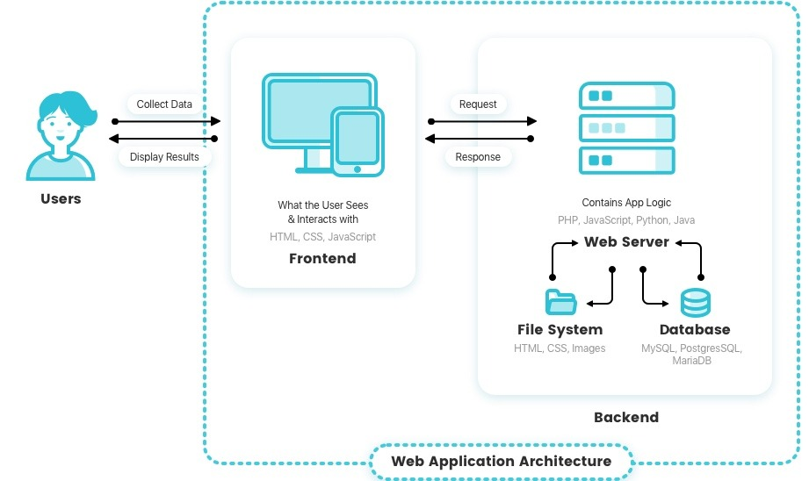

*Figure 1: The flow diagram depicts how a Web application operates.*

* To begin, the user will launch a web browser such as Chrome, Microsoft Edge, or Safari and enter the URL or click a link to the web application.
* The browser sends the request to the web hosting server.
* The request is received by the web server and forwarded to the appropriate application server.
* The application server processes the request and returns a response.
* The response is returned to the web server, which in turn returns it to the browser.
* The response is received by the browser, which then displays the web page to the user.

We now have a better understanding of the web application's workings as well as its significance. As a result, the Motorcycle Rental Management System project will create such a system to assist customers in managing the process and motorbike rental invoices. I will also create a source that is divided into two parts: the front-end, which receives requests from the browser, and the back-end, which processes the requests and sends responses to the other side.

2.2. Interaction Design

Interaction Design is the design of the interaction between the user and the product. Typically, when people discuss interaction design, they are referring to software products such as apps or websites.

It is the process of designing interactive digital products such as websites, mobile applications, and software interfaces with the goal of creating engaging and user-friendly experiences. Understanding user needs and behaviors, designing interfaces and interactions to meet those needs, testing and refining the design based on user feedback are all part of the process.

Interaction designers create the look, feel, and functionality of digital products, which includes visual design, information architecture, navigation, and user flow. To create effective and engaging user experiences, they employ a variety of design tools and methods such as wireframing, prototyping, user testing, and design thinking.

The goal of interaction design is to create products that are simple to use, intuitive, and enjoyable for users while also achieving business objectives such as increasing user engagement and improving user retention and increase conversions.

Following that, I will discuss five dimensions of Interaction Design. They are more than just a useful concept to keep in mind when developing a digital product. We'll look at these parameters to get a full picture of how users interact with digital products and what interaction design entails.

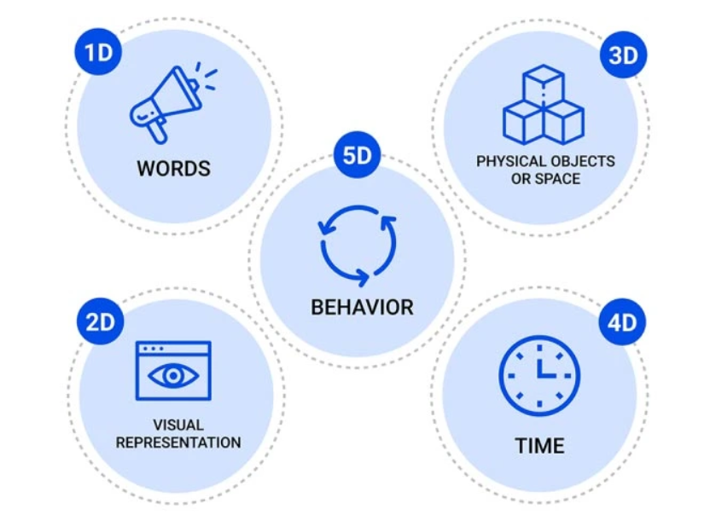

*Figure 2: Five dimensions of Interaction Design*

1. Word: The meaning of words is represented by this dimension. Words are extremely powerful in any field. They can assist users in quickly grasping the meaning and influencing them through word expressions. As a result, words must be familiar and easy to understand, communicated in a tone appropriate to the context, and used consistently throughout the product to convey information to the end user. In order to prevent misunderstandings among users when they use our product, we must carefully select vocabulary and proofread the language.
2. Visual representations: This dimension discusses visual elements that the user interacts with, such as typography, diagrams, symbols, or images. They frequently supplement the words used to convey information to the user. These elements are just as effective as "Words" because they quickly convey meaning to the user. In certain situations, this improves the user experience. However, we must exercise control over the use of these elements. When using our software, avoid overloading to avoid confusing users.
3. Physical objects or space: This dimension refers to the physical objects with which users interact while using the product. For example, using a mouse or touchpad on a laptop, a finger on a smartphone, and so on. Apart from physical objects, this dimension also refers to a type of physical space in which users interact with software. For example, users can use the laptop at work or at home. All of these factors have an impact on how people interact with products. As a result, some electronic device developers will attempt to optimize all interactions in all conditions and spaces that users may encounter.
4. Time: This is a unique factor because it is related to the amount of time the user spends interacting with the previous three dimensions. It entails creating designs for specific situations, such as the first interaction, repeated use, or when the user encounters an error. Furthermore, it is regarded as a criterion by which users can measure and evaluate their progress. This is a broad but critical aspect of implementing interaction design. Nobody wants a design that is responsive or takes a long time to manipulate. In today's world, time is synonymous with money, so optimizing and saving time is a top priority for businesses or corporations looking to improve their products.
5. Behavior: This final dimension consists of actions, reactions, activities, and presentations that are adaptable and understandable to all users. They frequently include questions such as the following: How do users react to product actions? How do customers interact with the product? Developers must learn and design their own products based on societal trends to ensure that users, both new and old, can easily use their application.

We now fully comprehend all interaction design concepts. The dimensions will be used in my Motorcycle Rental Management System project. With the first dimension, I will prioritize the use of basic English words so that users can understand the function and meaning of the website when they visit it. With the Visual representations element, I will consult some websites that provide bike rental services in order to select the appropriate fonts, colors, images, and charts for this project. Regarding the third factor, which is an objective factor, I can't completely control the user's space, so I built an application that can run on both laptops and phones to diversify users' needs so that they can use the product everywhere. In the fourth dimension, time, I will attempt to optimize the interaction time with the website, ensuring that all functions respond quickly enough to satisfy the basic user. Finally, with dimension behavior, I will listen to the user's request in conjunction with some other products to build appropriate and reasonable interactions for each function, ensuring user satisfaction.

2.3. HTTP protocol

In this section, I will discuss the protocol that was used in this project. Let's start with an explanation of what HTTP is:

* HTTP (Hypertext Transfer Protocol) is a standard protocol for sending data across the internet. It serves as the foundation for data communication on the World Wide Web. HTTP specifies how messages are formatted and transmitted, as well as the actions that the server and browser will take in response to various commands.
* HTTP operates on a client-server model, in which the client sends a request message to the server, and the server responds with a message containing the requested content or an error message if the request cannot be fulfilled. The most common application of HTTP is web browsing, which involves a user's web browser sending an HTTP request to a web server in order to retrieve web pages, images, videos, and other content.
* HTTP is a stateless protocol, which means that each request is handled independently, with no knowledge of previous requests. Web applications use cookies or other methods to store user data between requests in order to maintain session state. HTTP is designed to be extensible, allowing new features to be added to the protocol over time.
* In general, HTTP is a basic protocol that allows data to be exchanged over the internet, allowing users to access and interact with web content from anywhere in the world.

After we've grasped the fundamentals of the HTTP protocol, we'll compare it to a more specialized version of HTTPS.

* HTTPS (Hypertext Transfer Protocol Secure) is a secure version of HTTP that employs encryption to safeguard the privacy and security of data transmitted over the internet. It is widely used for online transactions, e-commerce, and secure communications between web servers and clients.
* HTTPS secures data sent between a web server and a client by combining the SSL (Secure Sockets Layer) or TLS (Transport Layer Security) protocol and an encryption algorithm. When a user uses HTTPS to access a website, their browser establishes a secure connection with the web server, encrypting all data sent between them.

So, what's the distinction between HTTP and HTTPS? The primary distinction between HTTP (Hypertext Transfer Protocol) and HTTPS (Hypertext Transfer Protocol Secure) is that HTTPS encrypts data transmitted between the server and client using a secure socket layer (SSL) or transport layer security (TLS) protocol, whereas HTTP does not.

This means that when we use HTTPS to access a website, the data transmitted between our browser and the web server is encrypted, making it much more difficult for someone to intercept and read. This is critical for websites that handle sensitive data like credit card numbers, login credentials, and personal information.

In contrast, when we use HTTP to access a website, the data sent between our browser and the web server is sent in plain text and can be easily intercepted and read by anyone with network traffic access. HTTP is thus less secure than HTTPS.

Another distinction between HTTP and HTTPS is the port used. HTTP uses port 80, while HTTPS uses port 443. When we use HTTPS to access a website, our browser automatically establishes a secure connection with the web server via the SSL/TLS protocol, which encrypts the data being transmitted.

Overall, the main distinction between HTTP and HTTPS is that HTTPS provides encryption and thus increased security when transmitting sensitive data over the internet. Due to the fact that the Motorcycle Rental Management System project is being used for a small household, we are currently only using HTTP protocol to transmit request and response between Client and Server. If the project grows in size, I will update using HTTPS.

2.4. MVC model

Knowing the MVC pattern is one of the basic elements of a web application product in the project. Model-View-Controller, or MVC, is a software development design pattern that divides an application's concerns into three interdependent parts: the model, the view, and the controller.

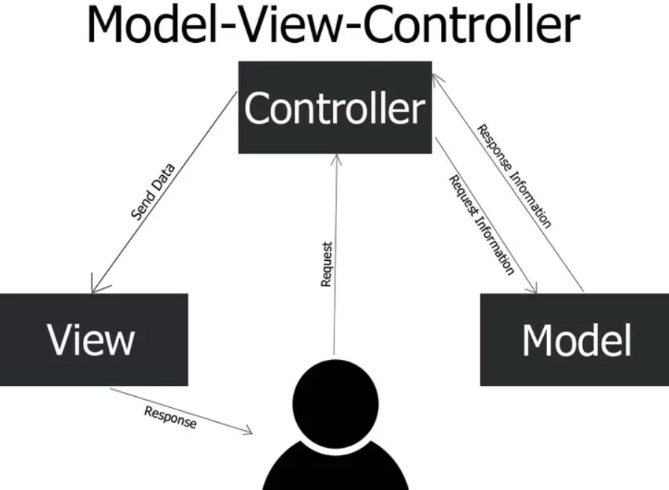

*Figure 3: The MVC model*

* The Model represents the application's data and business logic. It is in charge of data retrieval, manipulation, and storage.
* The View represents the application's user interface. It is in charge of displaying data to the user and allowing the user to interact with the application.
* The Controller acts as a go-between for the Model and the View. It receives user input through the View, processes the user's requests, and updates the Model as needed. It also updates the View with any changes made to the Model.

The MVC pattern allows programmers to create code that is simpler to maintain, test, and modify by dividing an application's concerns into these three parts. It also contributes to the overall structure of an application and encourages the use of best practices. Here are a few reasons why the MVC model is essential for web applications:

* Separation of Concerns: The MVC pattern divides the concerns of the application into three distinct components, each with their own set of responsibilities. This separation allows developers to work on different parts of the application without interfering with one another.
* Code Reusability: Separation of concerns makes code more reusable. Because the Model, View, and Controller are loosely coupled, changes to one component will not affect the others, making it easier to reuse code in other parts of the application.
* Better Code Organization: The MVC pattern encourages developers to write organized and modular code. It is easier to maintain, test, and modify code when the application's concerns are separated.
* Simpler Testing: MVC makes it easier to test individual application components. Separating the Model from the View and Controller during testing can make the process easier and more efficient.
* Improved User Experience: By dividing the application's logic and presentation, the MVC pattern contributes to an improved user experience. Developers can focus on making the user interface more user-friendly and responsive by keeping the application's business logic separate from its user interface.

Overall, the MVC design can assist developers in creating more robust, maintainable, and scalable web apps. At the Motorcycle Rental Management System project, I will use the MVC model with View as the Front-end source code (ReactJS) used to send requests to or receive responses from the Controller in the Back-end source. In addition, I have logically structured the Back-end source, including folders "Controller", "Entity", "Model", "Service", and "Specification" in accordance with the standard Spring Boot project structure. This structure follows the MVC pattern.

2.5. RESTful API

A RESTful API is an architectural style for designing web services that adheres to the principles of Representational State Transfer (REST). RESTful APIs are lightweight, scalable, and simple to use, which makes them a popular choice for developing modern web applications.

Resources in a RESTful API are identified by unique URIs and manipulated using standard HTTP methods such as GET, POST, PUT, and DELETE. These methods correspond to the four basic resource operations: retrieving, creating, updating, and deleting.

RESTful APIs also use standard data formats such as JSON (JavaScript Object Notation) or XML to represent data (Extensible Markup Language). This enables various applications and programming languages to interact with the API in a consistent manner.

Following that, we'll take a closer look at the RESTful API's components:

* API (Application Programming Interface): a set of rules and mechanisms that allow one application or component to interact with another. The API can return data for our application in common data types such as JSON or XML.
* REST (Representational State Transfer) is a data structure transformation technique and an architectural style for developing APIs. It facilitates machine-to-machine communication by using simple HTTP methods. Instead of using a URL to handle some user information, REST sends an HTTP request to a URL to process the data, such as GET, POST, DELETE, and so on.

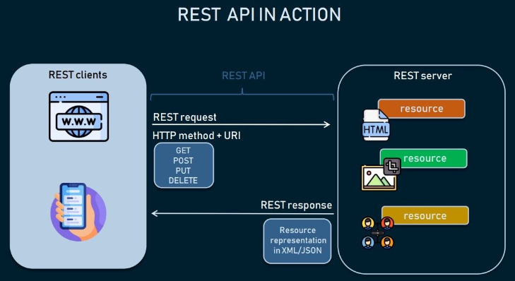

*Figure 4: REST API in action*

For a web application, RESTful APIs become important for several reasons: First, because RESTful APIs are lightweight and scalable, they are ideal for developing large-scale web applications that must handle a high volume of requests. Second, RESTful APIs are adaptable and simple to integrate with current systems because they can be used with any platform or programming language. Third, RESTful APIs are modular in the sense that they can be easily divided into smaller, reusable components, making them simple to maintain and update over time. The next reason is interoperability. RESTful APIs use standard data formats or XML to represent data like JSON, allowing different applications and programming languages to interact with the API in a standardized manner. Finally, there is the security factor. To protect sensitive information and guarantee that only authorized users have access to the API, standard authentication and authorization mechanisms, such as OAuth or API keys, can be used to secure RESTful APIs.

In this project, I used RESTful API to send requests and responses between the back-end and front-end. Almost every function - API of this project revolves around two HTTP methods, POST and GET. Even with the update and delete functionality, I still use POST to simplify the process of creating and managing APIs. In accordance with current web application standards, I have set the data's sending format to JSON. In addition, I tested each API using a program called POSTMAN. When a user takes an action on the website, ReactJS (client side) encodes the data into JSON format and sends it to the Back-end at the Controller via the preconfigured APIs. The backend will receive this JSON data and encode it so that Spring Boot can read it and convert it to Objects in the Java source. This principle also applies when data processed on the server side is sent to the client side. As a result, in order for this project to work, I must always run two sources simultaneously. Each source has its own role and objective, demonstrating the project's genuine professionalism.

2.6. Version Control

Version control is the management of changes made to the source code, documentation, and other assets of a software project. It is an essential procedure in software development that enables developers to keep track of code modifications and work productively together on a project.

When using version control, every time a file is modified, a new version of the file is created and used to track changes. Because of this, programmers can easily go back to a previous version of a file if necessary and track the changes that have been made to it over time.

Version control also makes it easier for multiple developers working on the same project to collaborate. It enables developers to work on the same codebase without overwriting each other's changes, and it enables developers to merge changes made by different developers into a single coherent codebase.

There are numerous version control programs accessible, including Git, Subversion, and Mercurial. Branch management, tagging, and merging are just a few of the features offered by these systems for managing and recording changes to software projects.

In software development initiatives, version control is crucial for a number of reasons: First is collaboration: multiple developers can collaborate on the same codebase at once without running into negotiation thanks to version control. Developers can share their changes, combine them into a unified codebase, and keep track of who made which changes using the mechanism it offers. Second is history/backup; version control systems keep track of all project modifications, enabling developers to examine and contrast various codebase versions. By doing this, programmers can find bugs, go back to previous iterations, and retrieve lost or deleted code. Third is accountability; version control makes it simpler to pinpoint who introduced a bug or a particular feature by keeping track of the changes made over time by various workers. This team member encourages members to take ownership of their actions and assume responsibility. The next factor is experimental features. By using version control, developers can test out various approaches to an issue, make new branches to work on experimental features, and merge those branches back into the main codebase once they are complete. Finally, version control is an essential component of a continuous integration workflow, in which changes to the codebase are immediately tested and integrated into the primary codebase. This makes sure that the codebase is always in release-ready condition and helps to find bugs.

I also used Git, a tool that will be described in more detail later, to manage this project's front-end and back-end sources. I'll upload that version to Git each time I complete a function or resolve a bug. Because the project is solely mine, all source code is presently stored in a single branch, master. I know it's not ideal and doesn't resemble large outside initiatives, but it saves me time when controlling source code in Git. In the future, if the project scale is expanded with a large team, I suggest using other branches to guarantee the product is fully controlled.

Chapter 3: Technology and Tools

3.1. Spring Boot

**3.1.1. What is Spring Boot**

Spring Boot is an open-source Java framework that enables the creation of standalone, production-grade Spring-based applications with minimum configuration. It is built on top of the popular Spring Framework and seeks to simplify and accelerate development by providing default configurations, embedded servers, and a broad variety of starter dependencies.

Spring Boot makes it simple to build Spring-based apps that can be deployed as standalone executables or as micro services running on cloud platforms. Among its many features are auto-configuration, which does away with boilerplate code, production-ready metrics, health checks, and tracking, as well as a potent command-line interface for controlling application development and deployment.

Spring Boot is highly modular and works with a broad range of popular databases, web servers, and other third-party libraries, making it an excellent option for developing scalable and high-performance applications. Its emphasis on convention over configuration and ease of use has made it a popular option among developers worldwide.

Today, Spring Boot is gaining more and more traction in all projects, big or small, for Java programming. Spring Boot has emerged as one of the top frameworks for all Java programmers. Some of the characteristics listed below will demonstrate why Spring Boot has become so popular:

* Modular and Lightweight: Because the Spring Framework is highly modular and lightweight, it is easy to integrate with other frameworks and technologies.
* Inversion of Control (IoC): The Spring Framework follows the Inversion of Control (IoC) principle, which makes managing dependencies between objects and components simple.
* AOP (Aspect-Oriented Programming): The Spring Framework also supports Aspect-Oriented Programming (AOP), which allows for the separation of cross-cutting concerns and improves code modularity.
* Simplified Development: Data access, security, testing, and web development are just a few of the tools and features available in the Spring Framework to help us get started faster.
* Flexibility: The Spring Framework is extremely adaptable and supports a variety of programming styles, including procedural, object-oriented, and functional programming.
* Community Support: The Spring Framework has a sizable and active developer community that offers a wealth of resources such as documentation, tutorials, and support.
* Enterprise-Ready: The Spring Framework is intended to be enterprise-ready, with features like transaction management, caching, and messaging that make it an excellent choice for developing large-scale and mission-critical applications.

**3.1.2. Differentiate between Spring Boot and Spring Framework.**

Some individuals will mistakenly refer to Spring Boot as Spring framework when discussing it. Consequently, I'll discuss how these two ideas vary from one another. Spring Boot and Spring Framework are both Java-based frameworks created by the Spring community, but they differ in several ways. Some of the most significant variations are as follows:

Configuration: The Spring Framework requires extensive configuration to set up an application, whereas Spring Boot uses annotations, properties files, and default configurations to simplify configuration.

* Opinionated and Flexible: Spring Boot has a stronger point of view than the Spring Framework. It provides a set of defaults and best practices that are suitable for the majority of projects, whereas the Spring Framework is more flexible and requires more configuration.
* Dependency Management: Spring Boot includes a dependency management system that simplifies dependency management, whereas the Spring Framework requires manual dependency management.
* Embedded Servers: Spring Boot includes embedded servers such as Tomcat, Jetty, and Undertow, making it simple to develop and test applications without requiring an external server. By default, the Spring Framework does not include an embedded server.
* Microservices: Because of its lightweight, modular architecture, Spring Boot is frequently used to develop microservices, whereas the Spring Framework is better suited to developing large-scale, monolithic applications.

**3.1.3. How to start Spring Boot project?**

After distinguishing between Spring Boot and Spring framework, we will learn how to build a basic Spring Boot project.

Step 1: Create a development environment.

* We'll need to get the Java Development Kit (JDK) and a Java Integrated Development Environment (IDE) such as Eclipse, IntelliJ IDEA, or NetBeans.

Step 2: Begin by making a new Spring Boot project.

* Using a Spring Boot starter project, we can create a new Spring Boot project. A starter project is a pre-configured project that contains all of the dependencies and configurations needed to get started. Using Spring Initializr or our IDE, we can create a starter project.

Step 3: Add dependencies.

* Using the Maven or Gradle build tools, we can add dependencies to our Spring Boot project. Spring Boot includes a variety of starter dependencies, such as preconfigured libraries and configurations for various modules, making it simple to add dependencies to the project.

Step 4: Write code.

* We can use Spring Boot's annotations and auto-configuration features to write our application logic. Spring Boot includes many annotations to help with development, such as @RestController, @RequestMapping, @Autowired, and many more.

Step 5: Test application.

* Using JUnit or Spring's testing framework, we can test our Spring Boot application. Spring Boot includes a variety of testing tools and features, such as mocking, integration testing, and more.

Step 6: Deploy application.

* We can run our Spring Boot application as a standalone executable or as a microservice on cloud platforms such as Amazon Web Services, Microsoft Azure, or Google Cloud Platform.

As a result, we have easily created a basic Spring Boot project. As we can see, Spring Boot offered a straightforward method for producing applications that were simple to develop, test, and deploy. Spring Boot minimizes the amount of boilerplate code and configuration required by offering default configurations, embedded servers, and a wide range of starter dependencies, making it the perfect solution for developing scalable and extremely performant applications.

**3.1.4. Knowledge that is required prior to learning Spring Boot**

Aside from knowing and using the Spring Boot framework, programmers must have some background knowledge in order to use it effectively. Because this is a high-end library, developers must have extensive previous experience. A new developer would struggle to approach this framework without these prerequisites. It will most likely take them some time to grasp the awesomeness of this library. These are some things we need to be aware of:

* Java: Because Spring Boot is a Java-based framework, we must have a solid understanding of the Java programming language, including object-oriented programming concepts, data structures, and algorithms.
* Spring Framework: Because Spring Boot is built on top of the Spring Framework, we must be familiar with the core concepts of Spring, such as Inversion of Control (IoC), Dependency Injection (DI), and Aspect-Oriented Programming (AOP).
* Web Development: Spring Boot is frequently used to create web applications, so we should be familiar with web development concepts such as HTML, CSS, JavaScript, and HTTP.
* Database Concepts: Spring Boot is frequently used to interact with databases, so we should be familiar with relational database concepts such as SQL, database design, and normalization.
* RESTful APIs: Spring Boot is frequently used to create RESTful APIs, so we should be familiar with RESTful API design principles, HTTP methods, and the JSON data format.
* Build Tools: Spring Boot projects can be built with build tools like Maven or Gradle, so we should be familiar with them.
* Testing: Because Spring Boot includes a variety of testing tools and features, we should be familiar with software testing concepts such as unit testing, integration testing, and mocking.

**3.1.5. Introduce about ORM**

Currently, the project's back-end source code is built from a Spring Boot project with entities, controllers, dependencies, etc. The feature I like about Spring Boot is the use of the ORM (Object Relational Mapping) framework. This is the technique used to map objects to database tables and vice versa. ORM frameworks enable developers to work with databases using an object-oriented paradigm, making it easier to write and maintain database code. In addition, ORM also provides a set of APIs that allow developers to interact with databases through the use of object-oriented concepts. From there, it eliminates the need to write boilerplate code for database interactions, reducing the amount of code that developers need to write and maintain. Besides, ORM also improves performance by optimizing database queries and caching data.

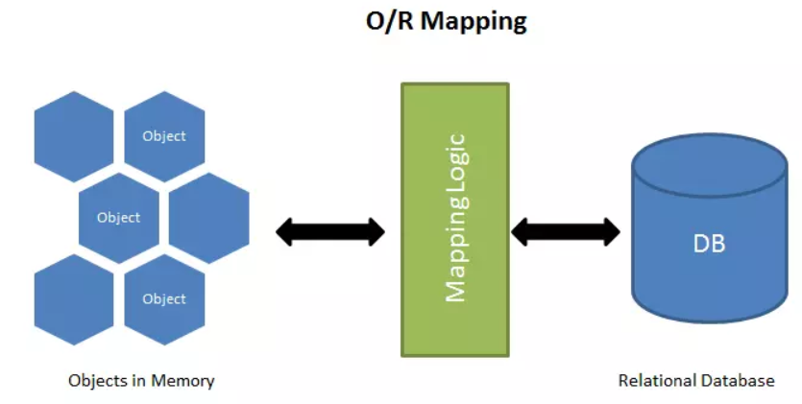

*Figure 5: ORM (Object Relational Mapping)*

**3.1.6. Introduce about Spring Data JPA**

Spring Boot, in addition to ORM, provides the concept of Spring Data JPA, which has greatly aided me in implementing queries to extract data from the database. Spring Data JPA is a Spring Data project module that provides support for implementing JPA (Java Persistence API) repositories using the Spring Framework. Spring Data JPA in Spring Boot provides a quick and efficient way to work with databases by minimizing the amount of boilerplate code required to interact with the database.

JPA is a Java object-relational mapping (ORM) specification. It enables the mapping of Java objects to relational databases and vice versa. JPA is supported by a number of ORM frameworks, including Hibernate, EclipseLink, and OpenJPA.

Spring Data JPA extends JPA by providing a repository abstraction layer that simplifies data access logic implementation. It provides a set of interfaces and default implementations for defining a repository for a specific domain entity. Developers can define custom repository methods simply by adding method signatures to the repository interface. Spring Data JPA generates the required SQL queries based on the method signatures. Here are some of the project's great features:

* Automatic CRUD Operations: Spring Data JPA includes default implementations for common CRUD (Create, Read, Update, Delete) operations that can be used as-is or customized.
* Query Methods: Spring Data JPA enables developers to define repository methods using naming conventions, which can then be used to create complex queries without the need for SQL code.
* Sorting and pagination: Spring Data JPA includes pagination and sorting support for query results.
* Auditing: Spring Data JPA includes auditing capabilities that enable developers to track entity creation and modification dates automatically.

As we can see, the two factors mentioned above have greatly aided my project in handling logic in the Service layer and data extraction. Because the current Motorcycle Rental Management System project only has a few basic functions, the queries are all initialized with JPA statements. If new and more complex functions are added later, we will have the opportunity to expose more advanced knowledge in using this library.

**3.1.7. Introduce about Specification of Spring Boot**

One of the skills I used for this project is Specification, in addition to using the fundamental query statements provided by Spring Data JPA. A Specification in Spring Boot is a set of guidelines or standards that can be applied to filter data from a database. Specifications are commonly used in conjunction with JPA and Spring Data JPA to define dynamic queries that can be constructed at runtime based on user input.

Spring Data JPA provides a Specification interface through which developers can define a set of rules for data filtering. A specification defines a set of criteria that can be combined using logical operators such as AND and OR. Each criterion is defined by a Predicate, which can be thought of as a boolean expression that evaluates to true or false.

Developers can create their own Specification implementations by implementing the Specification interface and supplying the required Predicate expressions. They can then use these Specifications to construct queries dynamically at runtime.

Here are some reasons why we should use Specification in a Spring Boot project alongside Spring Data JPA:

* Dynamic Queries: Specifications enable developers to create dynamic queries based on user input at runtime. This is useful when the query criteria are unknown in advance and can change based on user input. Developers can use Specifications to create queries that are more flexible and can handle a broader range of scenarios.
* Code Reusability: Specifications can be thought of as reusable components that can be applied to multiple queries. This can help to reduce code duplication and improve codebase maintainability.
* Type Safety: Specifications enable the type-safe definition of query criteria in Java code. This can help detect errors during compilation and make the code more robust.
* Separation of Concerns: Specifications enable developers to separate query logic from business logic. As a result, the codebase may become more maintainable and modular.
* Optimization of Performance: Specifications can help improve query performance by retrieving only the information needed from the database. Developers can ensure that the database retrieves only the necessary data by defining the query criteria ahead of time, which can result in faster query times and better overall performance.

In this project, I used Specification to handle queries that joined multiple tables together. This has significantly aided me in simplifying data extraction. I don't need to write a complicated query when joining multiple tables, especially in the project "Bike" entity. Every query concerning this object can be described as quite complex. Specification was extremely helpful to me when handling bike logic.

**3.1.8. Introduce about Spring Security – JWT token**

Spring Security is one of the final great features of Spring Boot. Spring Security is an authentication and authorization framework that is included in the Spring Boot project. It offers a full range of security features for web applications, such as access control, authorization, and authentication.

Spring Security is a security framework built on top of the Spring Framework that provides a number of security features that can be easily integrated into Spring Boot applications. Spring Security has the following key features:

* Authentication: Spring Security includes a number of authentication methods, such as form-based authentication, OAuth2, and JWT. It also allows for integration with third-party identity providers such as LDAP and Active Directory.
* Authorization: Spring Security includes a fine-grained authorization mechanism that allows developers to define access control rules at the URL or method level.
* CSRF Protection: Spring Security includes built-in protection against Cross-Site Request Forgery (CSRF) attacks.
* Session Management: Spring Security includes features for managing user sessions, such as session fixation protection and session timeout configuration.
* Security Events: Spring Security monitors and handles security-related events such as failed login attempts and successful authentication.
* Integration with Other Spring Modules: Spring Security integrates easily with other Spring modules like Spring MVC, Spring Boot Actuator, and Spring Data.

Spring Security is a robust and adaptable security framework that offers a comprehensive set of security features for web applications. Developers can easily add authentication and authorization features to their applications using Spring Security in Spring Boot, which helps to improve application security and protect against unauthorized access.

In this project, I used Spring Security to decentralize accounts using a JWT token. JWT (JSON Web Token) is a widely used standard for securely representing claims between two parties. JWT is frequently used as a means of authentication and authorization in the context of Spring Security.

JWT tokens can be used in a Spring Security configuration to validate a user's identity and grant or deny access to specific resources within an application. The basic flow of using JWT with Spring Security is as follows:

* The user logs in and enters their login information.
* The credentials are validated and a JWT token is generated by the server.
* The server returns the JWT token to the client.
* The JWT token is included in subsequent server requests by the client.
* Based on the contents of the token, the server validates the JWT token and grants or denies access to specific resources.

Overall, incorporating JWT tokens into a Spring Security configuration can aid in providing a secure and flexible method of authenticating and authorizing users in a web application.

3.2. ReactJS

**3.2.1. What is ReactJS?**

ReactJS (also known as React) is a well-known open-source JavaScript library for developing user interfaces (UI) for web applications. It was created by Facebook in 2011 and later released as an open-source project in 2013.

React enables developers to produce reusable UI components that can be used to quickly and easily build complex web applications. It employs a declarative syntax that allows developers to describe the desired UI state, with React handling DOM (Document Object Model) updates as needed. This method aids in improving the performance and efficiency of web applications.

React also supports a virtual DOM (Document Object Model), which is an in-memory representation of the actual DOM. This enables React to optimize UI updates and reduce unnecessary re-rendering. React can be used with other libraries or frameworks, and it is frequently used in conjunction with other technologies such as Redux, GraphQL, and Next.js.

Because of its performance, scalability, and ease of use, React has become one of the most popular JavaScript libraries for developing web applications. Following, I will list the advantages of this open-source:

* Improved performance: ReactJS employs a virtual DOM, which aids in the performance of web applications by reducing the number of direct manipulations of the actual DOM. This approach reduces unnecessary re-renders, improving the application's overall performance and speed.
* Reusable components: Developers can use ReactJS to create reusable components that can be used throughout the application. This reduces the amount of code that must be written, resulting in faster and more efficient development.
* Declarative syntax: ReactJS employs declarative syntax, which allows developers to more easily describe the desired UI state. This method allows developers to concentrate on what they want the application to do rather than how it should be done.
* Simple to learn: ReactJS has a simple API, making it simple for developers to learn and use. It also has a sizable and active user base that offers extensive documentation, tutorials, and support.
* SEO-friendly: ReactJS can be used to create search engine friendly web applications. Because React renders HTML on the server, search engines can easily crawl and index the content, resulting in higher rankings.
* Integration with other libraries: ReactJS integrates easily with other libraries and frameworks such as Redux, GraphQL, and Next.js, giving developers a flexible and extensible toolkit.

In general, ReactJS is a strong and flexible library that gives developers the resources they need to create scalable and fast web applications.

**3.2.2. Introduce about JSX**

One of the new skills acquired while working with ReactJS is JSX. In this section, I will introduce this concept. JSX (JavaScript XML) is a syntax extension for JavaScript that is used with ReactJS. It makes it simpler to create and work with the UI components of a React application by allowing developers to write JavaScript code that resembles HTML.

Although the syntax of JSX is similar to that of HTML, it is not the same. It is, instead, a syntax extension that enables developers to write JavaScript code that generates React elements. After that, these elements can be rendered in the browser.

The React compiler converts JSX code into regular JavaScript code that can be interpreted by the browser. This allows we to use familiar HTML-like syntax while still leveraging the full power of JavaScript and ReactJS.

I'll explain why it's preferable to use JSX instead of HTML in a ReactJS source code in this section. In fact, a React application can be created without the use of JSX. Developers can create React components in either pure JavaScript or plain HTML templates. However, using JSX will provide some of the following advantages:

* Improved developer experience: JSX enables developers to create components using familiar HTML-like syntax. This makes writing and reading code easier, particularly for those who are already familiar with HTML.
* Full JavaScript power: JSX enables developers to use the full power of JavaScript to create dynamic and interactive components. This includes constructing intricate UI components using loops, conditional statements, and other JavaScript features.
* Performance: To improve performance in React applications, JSX can be compiled. React can effectively update only the portions of the user interface (UI) that have changed rather than having to re-render the entire page by using a virtual DOM.
* Better React integration: JSX is designed to work in tandem with React components. It makes it simple to pass props and state between components and enables developers to easily create reusable components. Code is easier to write and read, especially for those who are already familiar with HTML.

To summarize, while it is possible to create React components using plain HTML or pure JavaScript, JSX provides several advantages that can make it easier and more efficient to create high-quality, performant applications.

**3.2.3. Virtual DOM**

The Virtual DOM (Document Object Model) is ReactJS's in-memory representation of the actual DOM. It is a lightweight and efficient copy of the actual DOM that contains all of the same properties and methods as the real DOM.

The Virtual DOM was developed as a technique for improving performance. When we make changes to the UI in a React app, the Virtual DOM is updated rather than the actual DOM. React then compares the updated Virtual DOM to the previous version to determine the specific changes that have been made.

After identifying the changes, React updates the actual DOM only where necessary, reducing the amount of work required to re-render the UI. This approach can result in significant performance improvements, especially for complex or large applications.

The Virtual DOM also enables developers to write declarative React components. Instead of writing complex code to manipulate the DOM directly, developers can simply describe the desired state of the UI and let React handle the updates.

In conclusion, a crucial component of ReactJS, the Virtual DOM enables better performance and a more declarative approach to UI development. React can update only the necessary parts of the UI by using a lightweight copy of the actual DOM, resulting in faster and more responsive web applications.

**3.2.4. Introduce about Component**

A component in ReactJS is a reusable building block that encapsulates the user interface and its behavior. It is a component of a website or user interface that can be reused across multiple pages or applications. A component may include HTML, CSS, and JavaScript and may receive and pass data to other components.

Components are the fundamental building blocks of ReactJS applications and are an essential component of the ReactJS framework. The code is kept organized and understandable with the aid of components. They make it possible for developers to create complex user interfaces by breaking them down into smaller, more manageable chunks.

Components are also important in ReactJS projects because they enable efficient user interface updates. ReactJS keeps track of changes to the UI using a Virtual DOM, and by breaking the UI down into smaller, modular components, ReactJS can more efficiently update only the parts of the UI that have changed.

Furthermore, components can be reused across multiple projects or pages, reducing the amount of code required and increasing the codebase's maintainability. Developers can save time and reduce the risk of introducing bugs or inconsistencies into the code by creating reusable components.

In conclusion, components are an important part of ReactJS projects because they help to organize, optimize, and maintain the code. They allow developers to create complex user interfaces by breaking them down into smaller, reusable building blocks.

**3.2.5. Introduce about Props and State**

**3.2.5.1 What is Props in ReactJS project?**

Props (short for "properties") are a data transfer mechanism in ReactJS that allows data to be passed from a parent component to a child component. Props are read-only and the child component is unable to change them.

Props are essential in ReactJS projects because they enable developers to create reusable and modular components. A component can be customized to meet the needs of the parent component by passing data down through props. Because each component can be made to handle a particular set of data, it is simpler to design complex user interfaces with numerous components.

Using props also allows developers to keep data flow in their application unidirectional, making it easier to reason about the application's state. Data flows from parent components to child components via props, and a child component can update the data by invoking a function passed down as a prop from the parent component.

Props can also be used to transfer event handlers or other functions from parent to child components. This can be useful for dealing with user interactions like button clicks and form submissions.

Props are an important part of ReactJS projects because they enable the creation of reusable, modular components that can be easily customized and combined. Developers can create complex user interfaces that are easy to reason about and maintain by passing data down through props.

**3.2.5.2. What is State in ReactJS project?**

In ReactJS, state is an object that stores the data that a component requires to render and manage its behavior. Unlike props, which are read-only and are passed down from parent components, state is managed internally by the component and can be modified by the component.

Because it enables components to manage user interactions and react to changes in the application state, state is important for ReactJS projects. A form component, for example, could use state to store the values of the input fields and update them as the user types. A button component may use state to keep track of whether it is currently pressed or not.

Components can be made dynamic and interactive by utilizing state, responding to user input and changes in the application's state. This can improve user engagement and intuitiveness.

State is also important in ReactJS projects because it enables efficient user interface updates. ReactJS will automatically re-render a component when its state changes, updating only the portions of the user interface (UI) that have changed. This allows for quick and efficient updates without the need to re-render the entire UI.

In general, state is an important factor of ReactJS projects because it enables components to be interactive and dynamic, responding to user input and changes in the application state. Internal state management allows components to be more efficient and responsive, resulting in a better user experience.

**3.2.5.3. Difference between Props and State:**

Props and state are both important concepts in ReactJS, but they serve different functions and have some significant differences:

* Ownership: Props are owned by the parent component and passed down to child components, whereas state is owned and managed by the component itself.
* Mutability: Props are read-only and cannot be changed by the child component, whereas state can be altered by the component.
* Initialization: Props are passed into a component when it is created, whereas state is initialized within the component's constructor or in a lifecycle method.
* Usage: Props are used to pass data from parent to child components, whereas state is used to manage internal data and handle user interactions.
* Data scope: Props are passed down from a parent component to a child component, limiting their scope to the component hierarchy, whereas state is only defined in the component in which it is defined.
* Triggers for updates: Changes to props are triggered by changes in the parent component, whereas changes to state are triggered by user interactions or other internal events within the component.

Props and state are used in a variety of ways within a ReactJS application, each serving a distinct purpose. Understanding the distinctions between the two is critical for developing effective and efficient components.

**3.2.6. Introduce Lifecycle methods of ReactJS**

Lifecycle methods in ReactJS are special methods that are called at specific points in a component's lifecycle. These methods enable developers to perform specific actions at various stages of a component's existence, such as when it is first mounted, updated, or unmounted from the DOM.

In ReactJS, lifecycle methods fall into three broad categories:

* Mounting methods: When a component is first created and added to the DOM, these methods are invoked. This category includes constructor(), static getDerivedStateFromProps(), render(), and componentDidMount() .
* Updating methods: These methods are called when the state or props of a component change and the component needs to be re-rendered. Static getDerivedStateFromProps(), shouldComponentUpdate(), render(), getSnapshotBeforeUpdate(), and componentDidUpdate() are examples of methods in this category.
* Unmounting methods: When a component is removed from the DOM, these methods are invoked. The componentWillUnmount() is the only method in this category.

In addition to these main categories, there are a few less commonly used lifecycle methods, such as static getDerivedStateFromError(), componentDidCatch(), and shouldComponentUpdate().

Lifecycle methods are important in ReactJS because they give developers hooks to perform actions at specific points in the lifecycle of a component. ComponentDidMount(), for example, can be used to retrieve data from an API when a component is first mounted, whereas componentWillUnmount() can be used to clean up any resources used by the component before it is unmounted.

Developers can control the behavior of their components at various points in their lifecycle using lifecycle methods, making it easier to create efficient and responsive user interfaces.

**3.2.7. Introduce about Hooks**

Hooks are a new feature in ReactJS 16.8 that allows developers to use state and other React features in functional components that were previously only available in class components.

Hooks are useful in ReactJS projects because they make it easier to build and manage state logic within components, making code more readable and easier to maintain. Hooks are useful for managing state, dealing with side effects, and integrating with other React features like context and refs.

As we've seen, Hooks is new, but it's already demonstrated its significance. In this section, I will discuss a few advantages of hooks for a ReactJS project.

* Improved code organization: Hooks enable developers to combine related stateful logic into a single function, making it easier to understand and maintain.
* Simpler component hierarchy: Hooks allow us to create complex functionality within a single component, eliminating the need for multiple layers of nested components.
* Reusable logic: Hooks make it simpler to build and maintain large-scale applications by allowing logic to be encapsulated and reused across multiple components.
* Simple to understand and apply: Hooks are easier to understand and use than traditional class components, requiring less boilerplate code.
* Improved performance: Developers can make more efficient and performant components by using hooks to manage state and side effects.

In conclusion, Hooks are an important feature in ReactJS because they simplify the process of building and managing stateful logic within functional components. Hooks can assist developers in creating better user interfaces and improving the overall performance of their applications by making it easier to create reusable and efficient components.

**3.2.8. Introduce about Redux**

Redux is a library for managing states in JavaScript programs, such as ReactJS. It provides a centralized store for managing the state of an application, and allows for predictable and efficient handling of state updates and data flow.

The application state is stored in a single "store" object in a Redux-based ReactJS project, which is then accessed as needed by individual components. Changes to the state are handled by "actions" that are sent to the store and then processed by "reducers" to update the state. This makes it simpler to create and maintain complex applications because it enables a clear separation of concerns between state management and UI components.

Redux is useful in ReactJS projects because it provides a scalable and predictable way to manage an application's state. Redux makes it easier to manage complex data flows and maintain a clear separation of concerns between different parts of the application by centralizing the state in a single store. It also provides a standardized method for handling state updates, making debugging and testing application behavior easier. Then, I will discuss about some benefit of redux:

* Managed by a centralized state: Redux makes application state management and maintenance simpler by allowing for a single source of truth.
* Predictable state updates: Redux makes it simpler to debug and predict the behavior of applications by adhering to a rigid pattern for handling state updates.
* Improved scalability: Redux makes complex data flows and state updates easier to manage, making it easier to build and maintain large-scale applications.
* Developer tools: Redux includes a number of developer tools and extensions to aid in debugging, testing, and maintaining the application.
* Interoperability: Redux can be combined with a variety of other frameworks and libraries, which makes it simpler to integrate with pre-existing codebases or create modular applications.

As we can see, Redux is an important tool for ReactJS projects because it can help improve the application's scalability, maintainability, and predictability. While it may add some complexity to the development process, it has the potential to make it easier to build high-quality, complex applications with clear separation of concerns and predictable behavior.

In the Motorcycle Rental Management System project, I used redux for some intermediate variables that run in real time, such as saving tokens for authorization and loading menus based on whether or not the user is logged in.

**3.2.9. Introduce about React Router**

One of the final terms I'd like to present in the ReactJS section is React Router. ReactJS programmers will be very familiar with this concept. We'll first discover what a React Router is.

React Router is a well-known ReactJS library that enables declarative routing in single-page apps. It enables programmers to specify routes for various application sites or components, and it manages navigation and rendering of these components based on the URL that is currently being used.

Because it offers a neat and reliable method to handle navigation within a single-page application, React Router is crucial for ReactJS projects. React Router makes it simpler to create complex applications with numerous views and user flows by defining routes and mapping them to particular components. Additionally, it makes handling browser history and URL parameters simpler, enabling more reliable and user-friendly navigation.

I'll then demonstrate how React Routing is useful.

* Route declaration: Developers can specify routes and navigation using React Router in a declarative manner, which makes it simpler to reason about application behavior.
* Component-based routing:  A modular and reusable strategy to developing complicated applications is made possible by React Router's ability to map routes to particular components.
* Changing routing: Applications with changing data and user flows can be built more easily thanks to React Router's ability to manage dynamic paths and URL parameters.
* Browser history management: React Router includes built-in management of browser history support, enabling seamless navigation and past tracking.
* Integration with other React features: React Router works in tandem with other React features such as context and hooks to provide a unified and uniform development experience.

React Router is an essential library for ReactJS projects because it enables declarative, component-based routing in single-page apps. React Router can help developers create more robust and user-friendly applications by offering a predictable and modular approach to navigation and user flows. In this project, I use the primary React Router to render the pages defined in the App.js file.

3.3. MySQL

I want to present MySQL as one of the following ideas to everyone. It is one of the most important pieces of information for this endeavor. Before I get into MySQL, let me explain what a Relation Database is.

**3.3.1. Introduce about Relational Database**

A relational database is a type of database management system (DBMS) that stores data in rows and columns in tables. The term "relational" refers to how data in a database is organized based on relationships between tables.

Each table in a relational database represents a specific type of data, such as customer information, product information, or order information. Each table is composed of rows that represent individual instances of data and columns that represent specific attributes or characteristics of the data.

The relationships between tables are defined by keys, which are used to connect data from one table to data from another. The primary key is the most common type of key, and it is a unique identifier for each row in a table. Foreign keys are used to connect related rows across tables.

One of the primary benefits of a relational database is its ability to support complex queries and reporting, making it an excellent choice for applications that require data analysis and business intelligence. Relational databases also provide a high level of data integrity and consistency, ensuring that the data in the database is accurate and reliable.

Popular relational database management systems include MySQL, Oracle, SQL Server, and PostgreSQL.

**3.3.2. What is MySQL?**

MySQL is a popular open-source relational database management system (RDBMS) that enables developers to efficiently store, organize, and retrieve data. MySQL is a popular database for websites and is widely used in web applications. I'll explain why MySQL has grown in popularity in the programming community.

* Open Source: MySQL is an open-source database, which means it is free to use and modify. This opens it up to a broad range of developers, from hobbyists to large corporations.
* Reliability: MySQL is a very dependable database management system that can handle large amounts of data without slowing down. As a result, it is ideal for web applications that must manage large amounts of data.
* Scalability: MySQL is designed to be scalable, which means it can handle an increasing amount of data as our application grows. This makes it a popular choice for startups and small businesses that need to manage their data effectively.
* Simple to Apply: MySQL is simple to use and works with a variety of programming languages, including PHP, Python, and Java. This simplifies the integration of MySQL into developer applications.
* Community Support: MySQL has a large and active developer community that contributes to its development and provides support to other developers. This makes it simple to find answers to questions and to seek assistance when necessary.

As we can see, MySQL is an important and popular database management system because it is dependable, scalable, simple to use, and has a large and active developer community. It is an excellent choice for web applications that must manage large amounts of data efficiently.

Despite using MySQL Server, I chose to create a non-relational database for the Motorcycle Rental Management System project. Non-relational databases are designed to expand horizontally, which means they can handle large amounts of data and high volumes of traffic by adding more servers to the database cluster. This makes them an excellent option for applications requiring large amounts of data, such as social media platforms or e-commerce sites. Furthermore, non-relational databases are schema-less, which means they do not require a predefined schema or data format. This makes it easier to add or remove data fields as required, and to adapt to changes in the data over time. Non-relational databases can be optimized for particular use cases and provide superior performance for certain types of queries or data access patterns in terms of performance. A key-value store database, for example, can provide extremely fast lookups for particular data items. Finally, about availability, non-relational databases are intended to be extremely available, with built-in redundancy and failover mechanisms that ensure data is always accessible. As a result, they are an excellent option for applications requiring high uptime and dependability.

**3.3.3. How does MySQL work?**

MySQL is a relational database management system that stores data in rows and sections in tables. The steps below describe how MySQL works:

* Installation: Before it can be used, MySQL must be downloaded on a computer or server. Setting up the server, establishing a root user account, and configuring server settings are all part of the installation process.
* Setting Up a Database: After installing MySQL, a database must be made to store data. A database is a group of tables that are organized based on their relationship to one another. MySQL supports multiple databases, each of which can hold multiple tables.
* Creating Tables: In a database, tables are made to hold particular kinds of data. Each table is made up of sections and rows. Columns specify the sort of data that can be kept, such as text or numbers, whereas rows contain the actual data.
* Inserting Data: By running SQL commands, data can be added to a database. SQL (Structured Query Language) is the language used to interact with MySQL. Insert statements are used to populate a database with information.
* Data Retrieval: SQL queries can be used to obtain data from tables. Queries are used to look for particular information or to retrieve all of the information in a table. The SELECT statement is used to obtain data from a table.
* Updating and Deleting Data: SQL commands can be used to update or remove data from tables. The UPDATE statement modifies current data in a table, whereas the DELETE statement removes data from a table.
* Security: MySQL includes a number of security features to safeguard the information saved in a database. User accounts with particular permissions can be established to control access to databases and tables. Passwords can also be used to protect individual accounts.

MySQL stores data in tables and allows us to build, modify, and retrieve data using SQL commands. It is a robust and adaptable database management system that can be used in a wide range of uses.

**3.3.4. Distinguish between MySQL and SQL server.**

Many people will confuse MySQL server with SQL server because they both have the term "SQL" in their names. Although these two concepts are comparable in nature, they are two distinct types of RDBMS. (relational database management systems). Because SQL server is very common among programmers, I will distinguish between these two types of RDBMS.

Ownership and Licensing: MySQL is an open-source RDBMS created by Oracle, whereas SQL Server is a proprietary RDBMS developed by Microsoft. MySQL is available under the GNU General Public License, whereas SQL Server is a commercial product that needs a license.

* Platform Support: MySQL is a cross-platform database system that can operate on Windows, Linux, and macOS. SQL Server, on the other hand, is mainly intended to run on Windows, with some limited support for Linux.
* Scalability: Both MySQL and SQL Server are intended to be scalable, but they take different approaches to scaling. MySQL is intended to be distributed, which means it can scale horizontally across numerous servers. SQL Server, on the other hand, is intended to scale vertically, which means it can handle larger workloads by adding more processing capacity to a single server.
* Performance: Both MySQL and SQL Server are high-performance database platforms, but they have distinct advantages. MySQL is designed to execute basic queries quickly and to support a large number of concurrent connections. SQL Server is designed for complex queries and can manage big datasets.
* Tooling: MySQL and SQL Server each have their own collection of database management and administration tools. MySQL Workbench is a popular tool for managing MySQL databases, whereas SQL Server Management Studio is the main tool for managing SQL Server databases.

In conclusion, both MySQL and SQL Server are powerful RDBMS platforms that can be used in a variety of applications. The decision between them will be influenced by variables such as platform support, scalability requirements, and performance requirements. For this project, I chose MySQL over SQL server because it is free and has strong support for integrating with Spring Boot projects.

**3.3.5. Introduce about MySQL Workbench**

Following that, I'll go over a well-known MySQL utility called MySQL Workbench. This is a visual database design and management tool for MySQL. It includes a graphical user interface (GUI) for designing, creating, and administering MySQL databases. MySQL Workbench includes the following features:

* Data Modeling: MySQL Workbench's graphical interface enables us to view design, create, and modify database schemas. Tables, relationships, and indexes can be created, and the schema can be viewed in a number of formats.
* SQL Development: MySQL Workbench contains a SQL editor with syntax highlighting, code completion, and query profiling. We can write and execute SQL statements, build and edit stored procedures, and handle triggers.
* Database Administration: MySQL Workbench enables us to handle user accounts, backup and restore databases, and monitor server status. We can examine server logs, run diagnostics, and configure server parameters.
* Database Migration: MySQL Workbench contains a migration wizard for migrating data from other databases to MySQL. Data can be migrated from Microsoft SQL Server, Oracle, PostgreSQL, and other databases.
* Performance evaluation: MySQL Workbench contains database performance analysis tools, such as the ability to watch server status, analyze query performance, and profile SQL code.
* Collaboration: MySQL Workbench contains features for collaborating with other developers, such as version control integration, team collaboration, and the ability to exchange database designs and models.

MySQL Workbench is a powerful tool for handling MySQL databases that includes tools for database modeling, SQL development, administration, migration, performance analysis, and collaboration. I also use this utility because it is free and is the primary MySQL support tool.

3.4. SCSS

Following that, I will discuss SCSS, a language used to style webpages. This is a more advanced form of CSS.

**3.4.1. What is SCSS?**

Sassy Cascading Style Sheets, or SCSS, is a preprocessor programming language that creates CSS. It is basically a CSS extension that adds additional functionality and features to CSS, making it easier and more efficient to write and handle stylesheets.

Since SCSS is a superset of CSS, every legitimate CSS rule also applies to SCSS. SCSS, on the other hand, introduces features such as variables, nesting, inheritance, mixins, and more. These features make it easier to create reusable and maintainable stylesheets, particularly for big and complex projects.

**3.4.2. Advantages of SCSS**

The SCSS has the following advantages:

* Variables: SCSS enables us to use variables to store and reuse values, which can make our stylesheets more efficient and easier to maintain. For example, we could use a variable to keep our brand color and then easily update it across our entire stylesheet. For example: $primary-color: #007bff;
* Nesting: SCSS enables us to nest CSS selectors within each other, making it easier to write and read complex stylesheets. This can help us prevent repetition and make our code more modular.
* Mixins: SCSS enables us to create and reuse sets of styles using mixins, which can help us avoid duplicating code and make our stylesheets more consistent.
* Inheritance: SCSS enables us to share styles between selectors by using inheritance, which can help us avoid duplicating code and make our stylesheets more efficient.
* Modularity: SCSS enables us to divide our stylesheets into smaller modules, which can help us organize our code and make it easier to maintain.

**3.4.3. Disadvantages of SCSS.**

The SCSS has the following disadvantages:

* Learning curve: SCSS is more difficult to learn than plain CSS because it needs knowledge of its syntax and features.
* Compilation: Before it can be used in a web browser, SCSS must be compiled into CSS, which can add an additional step to our workflow.
* Performance: Depending on the complexity of our stylesheets, using SCSS may result in larger file sizes and possibly slower page load times.
* Tooling: Using SCSS may necessitate the setup of extra tooling or build processes, which can complicate our development workflow.
* Browser support: Some older web browsers may not completely support all of SCSS's features, resulting in inconsistencies or errors in our stylesheets.

**3.4.4. Differentiate between SCSS and CSS.**

In this part, I will demonstrate the various features of SCSS and CSS. We can then envision the differences between these two languages.

* Syntax: SCSS has a distinct structure from CSS. While CSS uses curly braces and semicolons to divide style declarations, SCSS uses indentation and nesting to combine related styles together.
* Variables: SCSS allows us to declare and use variables in our stylesheets, which can save time and reduce repetition. If we wished to change a value throughout our stylesheet, we would have to explicitly replace every instance of it in CSS.
* Mixins: Mixins are reusable groups of style declarations that can be applied to numerous elements, and SCSS allows us to describe them. In CSS, we would have to manually copy and paste the same styles across various rulesets.
* Inheritance: SCSS allows us to share styles between selectors by using inheritance, which can save time and reduce duplication. In CSS, we would have to manually copy and paste the same styles across various selectors.

3.5. Firebase

This part will go over a specialized tool for storing images pertaining to cloud computing. Firebase is the name of this application. It is an essential tool in the Motorcycle Rental Management System project.

**3.5.1. What is Firebase**

Firebase is a Google-owned mobile and web application development tool that offers a variety of backend services such as authentication, real-time databases, hosting, cloud storage, and messaging. It helps developers to create high-quality mobile and web apps rapidly, with minimal setup and maintenance.

Firebase provides a real-time database that can be used to store and synchronize data in real-time between numerous clients. It employs NoSQL technology, which makes it easier to store and retrieve data in a flexible way without requiring developers to build complex database schemas.

Firebase also provides authentication services, allowing developers to quickly integrate sign-in and sign-up features into their applications. Support for major social media platforms such as Google, Facebook, and Twitter is included.

Furthermore, Firebase offers hosting services, making it simple to deploy web applications rapidly and securely. It also provides cloud storage for storing and serving information, as well as messaging services for sending tailored messages to users.

In the end, Firebase is a powerful platform for developing mobile and web apps that has grown in popularity among developers due to its ease of use and extensive feature set.

**3.5.2. Some benefits of Firebase**

* Scalability: Firebase provides cloud storage services that can scale automatically as our application's utilization grows. This means we won't have to think about managing our own servers or infrastructure to meet our application's storage requirements.
* Accessibility: Firebase enables us to view our stored images from any application or web browser. This can make managing our image data and sharing it with other users simpler.
* Security: Firebase includes built-in security features to safeguard our stored data, such as access controls and encryption. This can help to ensure that our image data is private and protected from unauthorized access.
* Integration: Firebase integrates easily with other Firebase services, such as authentication and real-time databases, making it easier to create a comprehensive application that utilizes multiple Firebase services.
* Cost: Firebase has a generous free tier that allows us to store and access a certain quantity of data each month for free. For smaller applications or initiatives with limited budgets, this can be a cost-effective solution.

**3.5.3. Configure Firebase in a ReactJS project.**

Step 1 is creating a Firebase project: Go to the Firebase Console and start a new Firebase project.

Step 2 is installing Firebase SDK: Install the Firebase SDK in our ReactJS app by running the following command in the terminal. For example, npm install firebase

Step 3 is initializing Firebase: In our ReactJS project, start Firebase by creating a new Firebase configuration object with our Firebase project credentials.

Step 4 is using Firebase services: We can use Firebase's services in our ReactJS components after we've started it.

Please keep in mind that based on the requirements of our application, we may need to configure Firebase authentication and other services separately. More information about setting and using Firebase services in ReactJS can be found in the Firebase documentation.

3.6. Git

Git is one of the finest tools for developers to use to manage source code versions. Despite the fact that there are many tools to support this industry today, Git maintains a strong position in the developer community.

**3.6.1. What is Git?**

Git is a popular version control system (VCS) that enables software developers to manage and track changes to their code over time. It was developed by Linus Torvalds in 2005 and has since grown to be one of the most widely used VCS tools in the software development sector.

Git works by establishing a repository, or "repo," which is a central location where developers can store their code and monitor changes to it. Developers can make changes to their code locally on their own computers and then send those changes to the central repository. Other developers can then pull those modifications from the repository and incorporate them into their own work.

Git enables developers to collaborate on the same codebase even if they are spread out across various parts of the globe, which is one of its main advantages. It also includes branching and merging features, which enable developers to work on separate features or versions of code at the same time and then merge those changes back into the primary codebase.

**3.6.2. Advantages of Git**

Here are some of the advantages of using Git for source code management:

* Distributed development: Git is a distributed version control system, allowing every developer to have a local copy of the codebase and work separately on it. This enables developers to work offline and successfully collaborate with other team members who may be located in different parts of the globe.
* Version control: Git enables developers to keep track of changes made to the codebase over time. This means that developers can easily revert to earlier versions of the code if necessary, as well as monitor who made changes and when.
* Branching and merging: Git has strong branching and merging capabilities, allowing developers to work on different features or versions of code at the same time and then merge those changes back into the primary codebase. This makes it simple to manage large codebases and successfully collaborate with other team members.
* Collaboration: Git allows developers to work together on the same codebase even if they are in different parts of the globe. It has tools like pull requests, code reviews, and commenting that aid in collaboration and ensure that code changes are correctly reviewed and tested.
* Open-source community: Git is an open-source tool, which means that it has a big developer community that contributes to its development and support. This community offers a wealth of resources and expertise that can be beneficial to developers who are just beginning to use Git.

**3.6.3. Some terms in Git**

When using Git, we must grasp some of the following concepts. These terms are practically used by every version control tool, making it accessible to the vast majority of individuals. These include:

* Repository: A repository (also known as a "repo") is a central location where developers can store their code and monitor changes to it.
* Commit: A commit is a collection of modifications made to the codebase that are saved in the repository. It contains a message that explains the changes.
* Branch: A branch is a separate version of the codebase that enables developers to work on different features or versions of the code at the same time.
* Merge: Merging is the process of integrating changes from distinct branches into the main codebase.
* Pull: Pulling is the process of obtaining modifications made to the repository by other writers and incorporating them into your local copy of the codebase.
* Push: Pushing is the process of uploading modifications made to your local copy of the codebase to the central repository.
* Conflict: When Git is unable to automatically merge changes made to different branches, a conflict arises. In this situation, developers must carefully resolve the conflict by reviewing the changes and deciding how to merge them.
* Fork: A fork is a copy of a repository that enables developers to make modifications to the codebase independently of the initial repository.
* Pull request: A pull request is a method for developers to send modifications made to a branch of a repository for review and possible merging into the main codebase.
* Gitignore: The “gitignore” file is a file that defines which files or directories should be ignored by Git when tracking changes to the codebase.

**3.6.4. Introduce about GitHub**

GitHub is a web-based platform that hosts Git repositories as well as a variety of collaboration and administration tools for software development teams. It is one of the biggest and most popular hosting platforms for open source software projects, and it is used by millions of developers and organizations worldwide.

GitHub enables developers to store their code in repositories, which can be public or private. Public repositories can be viewed and accessed by anyone, whereas private repositories are only available to authorized users. GitHub also offers a variety of collaboration tools, such as pull requests, issue tracking, and code review, which can help to enable developer collaboration and ensure that changes to the codebase are properly reviewed and tested.

GitHub, in addition to holding Git repositories, offers a variety of additional features and tools, such as wikis, project management tools, and integrations with other software development tools. It has become an essential tool for open source software development, and it is used by many well-known software projects and organizations, including Microsoft, Google, and the Linux Foundation.

Overall, GitHub is a powerful platform for managing and collaborating on software development projects, and it is an essential tool for developers and organizations looking to create and manage high-quality software. In this project, I used GitHub to handle the source code by logging in to the University of Greenwich Vietnam's Gmail account.

**3.6.5. Introduce about Git Desktop**

Git Desktop is a graphical user interface (GUI) for Git that enables developers to manage and monitor changes to their codebase visually. It makes it simple for developers to perform typical Git chores like creating and cloning repositories, committing changes, and merging branches.

Although the command-line interface (CLI) and npm statements can be used to control the version of source code, Git Desktop can make the procedure simpler and more effective, particularly for developers who are less accustomed to using the command line. Git Desktop provides a visual interface that shows the current state of the codebase, including any changes made but not yet committed, and enables developers to easily commit changes, create and merge branches, and view commit history.

Git Desktop can, in general, assist developers in managing and tracking changes to their codebase more quickly and efficiently, which can reduce errors and save time. It can be a helpful tool for developers who prefer a visual interface for managing their codebase or are less familiar with the Git CLI.

3.7. IntelliJ

3.8. Visual Code

3.9. Postman

Chapter 4: Software Product Requirements

4.1. Review/overview of other similar products

4.2. User Stories – Product Backlog

4.3. Use Case Diagram

4.4. ERD

4.5. Sitemap

Chapter 5: Review of Software Development Methodologies

Chapter 6: Design and Implementation of our demo product

Chapter 7: Conclusions